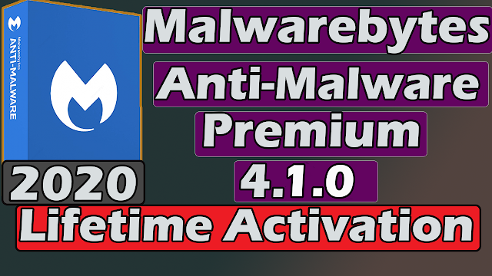
Malwarebytes PREMIUM 4.1.0 - LIFETIME METHOD | 8.62 MB
1. Guide:
Note: Application requires Admin privileges
Allow run the program as an administrator.
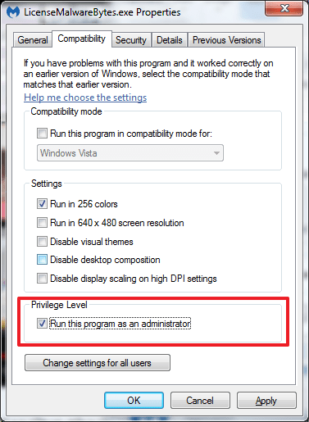
Run LicenseMalwareBytes.exe in commandline (CMD) as administrator. For more details, please run LicenseMalwareBytes.exe --help.
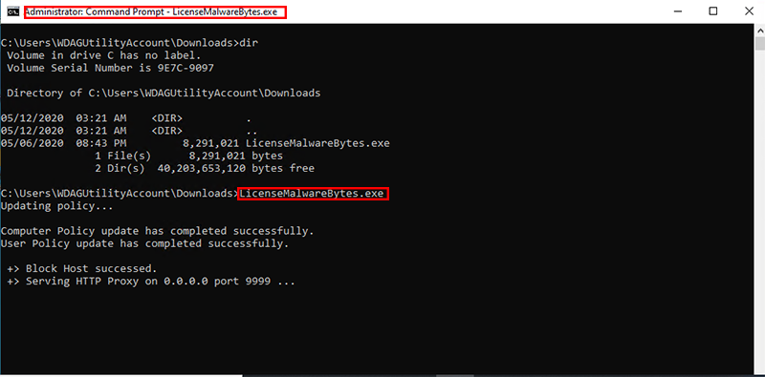
I also tested it by right-clicking, run as administrator on the license file and it ran directly on the console.
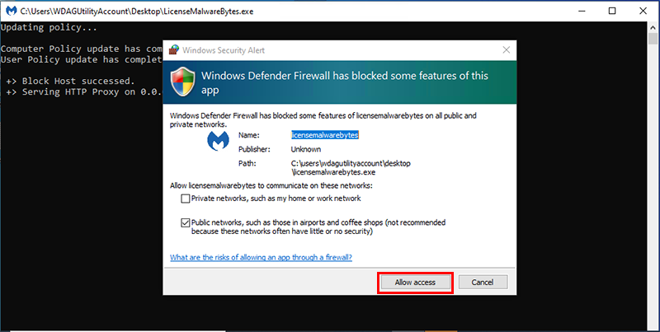
Open MalwareBytes, select Settings > General. Turn on Proxy server. After enter IP into Address and PORT into Port.
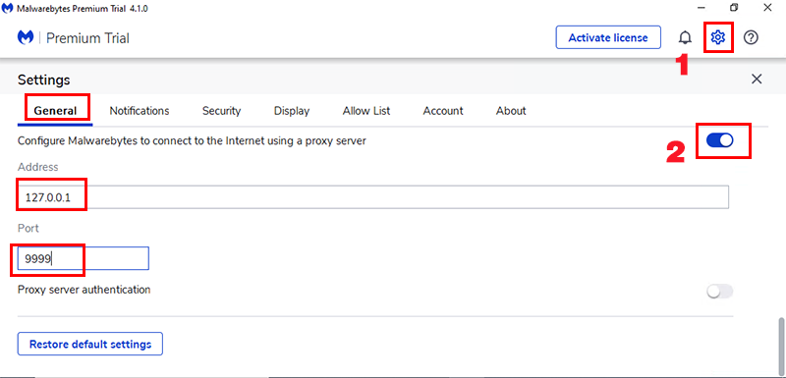
After that, switch tab Account.
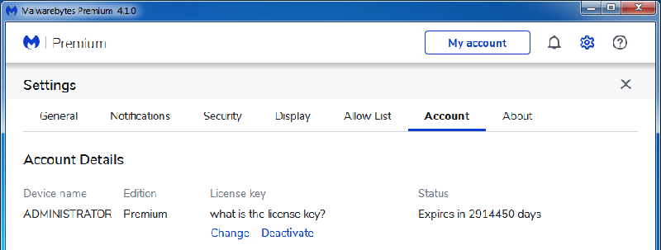
Not yet, return tab General. Go to Proxy server, turn off it.
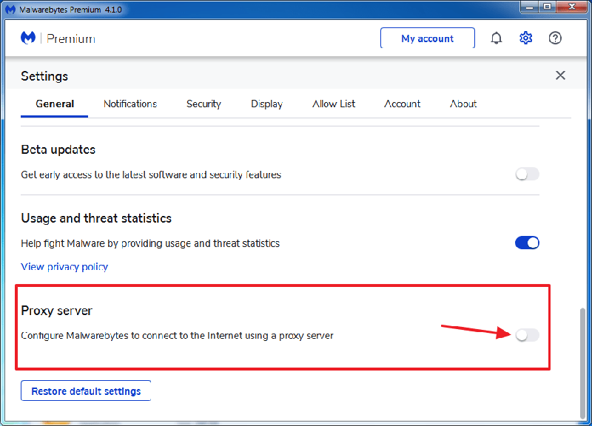
Return tab Account. You will see.
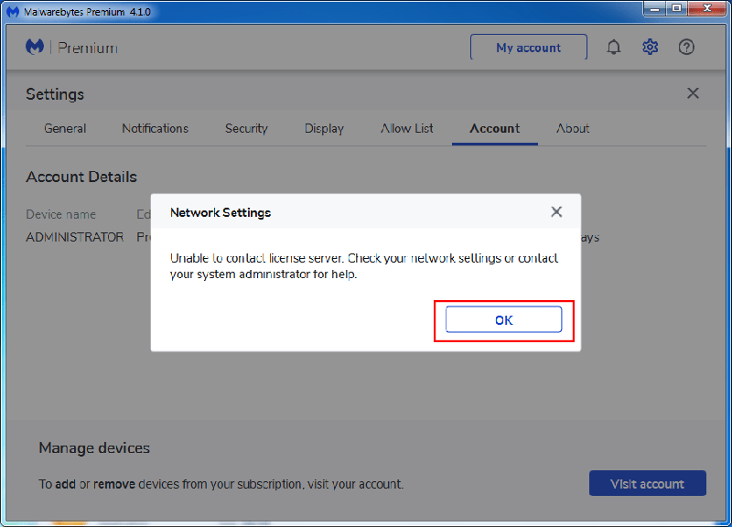
Don’t worry about it. Click OK and done.
NOTE: Some screenshots are cut off because I tried it in "Windows Sandbox", others are the original ones from the author's thread.
2. INSTRUCTIONS:
1. Install MB version 4.1.0 free located in the "Setup free" folder (if you have doubts look at 2.1 OTHER INSTALL SCREENSHOT)
2. Open MalwareBytes, select Settings > General. Turn on Proxy server. After enter IP 127.0.0.1 into Address and PORT 9999 into Port.
3. Close MalwareBytes
4. Run as administrator LicenseMalwareBytes.exe (located in the "Licence Premium" folder) in CMD (I also tested it by right-clicking, run as administrator on the license file and it ran directly on the console.)
5. Minimize and leave running in the background (I didn't try closing the console)
6. Open MalwareBytes, switch tab Account and see if the premium license is already
7. Not yet, return tab General. Go to Proxy server, turn off it.
8. Switch tab Account, you should already see the premium license
9. Done
2.1 OTHER INSTALL SCREENSHOT
Spoiler: Other screenshot
